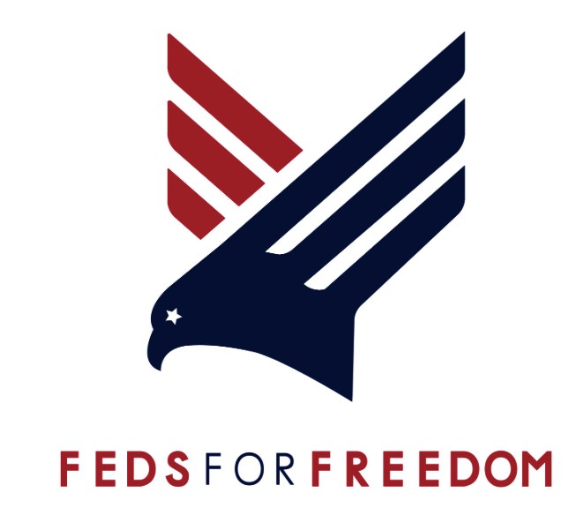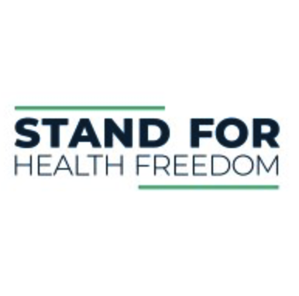

**[Proposed Legislation]**

**National Medical Freedom Act**

119TH CONGRESS              **H. R. _____**

A Bill to prohibit any United States (U.S.) business, hospital, medical establishment, or school from requiring another person to receive a medical intervention.  This Bill makes it a discriminatory action to treat a person differently that has not received or used a medical intervention.  Such discriminatory behavior includes denying access to medical care, surgeries, or prenatal care, or denying access to education (e.g. K-12 or higher education).

**IN THE HOUSE OF REPRESENTATIVES**

**May 13, 2025**

**A BILL**

To ensure the continued U.S. public safety and freedom from discrimination, this Bill makes it a discriminatory action to toward any person who has not received or used a medical intervention and prohibits U.S. businesses, medical, and education centers that receive U.S. funding from requiring a person to receive a medical intervention. This Bill specifically halts any discriminatory actions that prevent persons who have not received a medical intervention from access to medical care, surgeries, dental care, or access to education and education services.

This Bill, be it enacted by the Senate and House of Representatives of the United States of America, in Congress assembled, may be cited as the “Medical Freedom Act”.

**IN GENERAL**

The U.S. Bill of Rights, U.S. Constitution, the Civil Rights Act of 1964, and State and Local laws, including State Human Rights Acts, secure for U.S. citizens freedom from discrimination because of race, color, religion, sex, pregnancy, national origin, age, handicap, or marital status; these U.S. Laws and Rights also, thereby, protect and preserve public safety, health, and general welfare, and promote the interests, rights, and privileges of individuals.

This Bill further protects U.S. citizens from discrimination, making it a discriminatory action for any U.S. business, medical, or education establishment to deny treatment or access to individuals who have not used or received a medical intervention.  This Bill also makes it a discriminatory action for any such establishment to treat a person differently because they have not received or used a medical intervention and prohibits requiring or coercing   any person to receive or use medical interventions.

Several State Legislators have already brought similar anti-discriminatory Bills to their States, including Montana, Tennessee, and Florida; the Governor of Idaho just signed into law Senate Bill 1210, making it unlawful to discriminate against citizens who have not used or undergone medical interventions. Congress must also act now to protect the U.S. public from ongoing discriminatory actions that prevent lifesaving access to medical treatments and education opportunities. This Bill directs States to impose penalties for discriminatory violations.

**IMPLEMENTATION**

**A. Medical Mandates Prohibited**

Upon implementation of this Bill, it is deemed a discriminatory practice for any business, medical establishment, or education center, including but not limited to, hospitals, surgery centers, pediatric practices, and/or any individuals working therein, which receive U.S. Federal funding or aid from the following actions:

(1) To refuse, withhold from, or deny a person medical care or treatment, including but not limited to a service, good, medical facility access, an organ transplant and/or surgery access, based on the person's medical intervention status;

(2) To refuse, withhold from, or deny to a person access to education, education services, or opportunity based on the person's medical intervention status.  A school shall also not mandate a medical intervention for any person to enter campus or school buildings, or be employed by the school;

(3) For a business entity conducting business in the U.S. to refuse to provide any service, product, admission to a venue (e.g. deny access to an entertainment event to a ticket holder), or transportation to a person because that person has or has not received or used a medical intervention.

(a) Exclusion: A business entity conducting business in the U.S. shall not require a medical intervention as a term of employment unless required by Federal law such as in the case of military service or in such cases where the terms of employment include travel to foreign jurisdictions requiring a medical intervention as the only means of entry or where the terms of employment require entry into a place of business or facility in a foreign jurisdiction and such place of business or facility requires a medical intervention as the only means of entry. In any such instance where an employee is required to obtain or use a medical intervention due to travel to a foreign jurisdiction or entry into a place of business or facility in a foreign jurisdiction, said requirement shall either be included in a valid written employment contract between the employer and the employee or, when a written employment contract does not exist, advance written notice shall be provided to an impacted employee no less than fourteen (14) days prior to such employee being required to receive or use a medical intervention.

(4) To humiliate or harass a person based on the person's medical intervention status or whether the person has an immunity passport.

(5) To coerce patients or students to take or use a medical intervention.

(6) Unless required by Federal law, no State, County, or local government entity or U.S. official shall require any person to receive or use a medical intervention.

(7) Unless required by Federal law, no State, County, or U.S. government entity or official shall require any person to receive or use a medical intervention as a condition for:

(a) Receipt of any U.S. government benefit;

(b) Receipt of any U.S. government services;

(c) Receipt of any U.S. government-issued license or permit;

(d) Entrance into any Federal or public building, land or space; or

(e) Use of public transportation.

(8) No U.S. State, County, or local government, or business entity shall provide or offer any different salary, hourly wage, or other on-going compensation or benefits to an employee based on whether the employee has or has not received or used a medical intervention.

(9) The prohibition on medical interventions shall not apply to any situation where personal protective equipment, items, or clothing are required by a business entity in the public or private sectors based on existing traditional and accepted industry standards or Federal law.

Upon implementation of this Bill, all U.S. States and Territories will impose civil penalties for each discriminatory violation, as defined in (1) - (9).

**REMEDY**

1. If a governmental entity or person is found to be in violation of this act
   1. the affected citizen may do any or all of the following:
      1. pursue an employment discrimination claim,
      2. bring an action in state court, or
      3. alert the [Attorney General/Department of _______] of the violation.
   2. the governmental entity or person in violation shall face civil penalties of $5,000 for the first individual instance, and $10,000 for each individual instance that follows, and face ___________license suspension or revocation by the Department of ___________.

**DEFINITIONS**

As used in this Bill:

(1) "Business entity" means any person or group of persons performing or engaging in any activity, enterprise, profession, or occupation for gain, benefit, advantage, or livelihood, whether for profit or not-for-profit.

"Business entity" shall include but not be limited to:

(a) Self-employed individuals, business entities filing articles of incorporation, partnerships, limited partnerships, limited liability companies, foreign corporations, foreign limited partnerships, foreign limited liability companies authorized to transact business in the U.S., business trusts, and any business entity that registers with the U.S. Department of Labor; and

(b) Any business entity that possesses a business license, permit, certificate, approval, registration, charter, or similar form of authorization issued by the U.S. government, any business entity exempt by law from obtaining such a business license; and any business entity operating unlawfully without such a business license.

(2) "Foreign jurisdiction" means any country or nation outside the U.S.

(3) "Medical intervention" means a medical procedure, treatment, device, drug injection, medication, or medical action taken to diagnose, prevent, or cure a disease or alter the health or biological function of a person.

(4) "School" means any public, private, or parochial preschool; any kindergarten, elementary, or secondary school; any postsecondary institute of education, including trade schools, colleges, and universities; or any

other institutes of primary, secondary, or higher learning operating in the U.S..

(5) "Ticket issuer" means an individual or entity providing tickets to an entertainment event, including any of the following:

(a) The operator of the venue where an entertainment event occurs;

(b) The sponsor or promoter of an entertainment event;

(c) A sports team participating in an entertainment event or a league whose teams are participating in an entertainment event;

(d) A theater company, musical group, or similar participant in an entertainment event; or

(e) An agent of any individual or entity described in this subsection.

(6) “Immunity passport" is a document, digital record, or software application indicating that a person is immune to a disease, either through vaccination, immunization, injection, medical treatment, or infection and recovery. 